We collected the cancer data from different hospitals across United States of America. The data is in the form of text format. We want to convert text into numerical data (Text Classification) depending upon the Number of polyps, shape, size, location and treatment method. Each record gives the patient cancer information sometimes the patient may have cancer in multiple locations, so we are trying to have data sorted according to location as parameter.

Data Dictionary

|  |  |
| --- | --- |
| Random _ ID | Patient ID |
| Number of sessile | Data type: Number |
| Size of sessile | Small  Diminutive  SEMI  Medium  Large |
| Size of sessile in number | Number units(MM,CM) |
| Shape of sessile | |  | | --- | | SESSILE | | PEDUNCULATED | | FLAT | | MASS | | SERRATED | | SMOOTH | |
| Location of sessile, | |  |  | | --- | --- | | Names of location | Other names of location according to data | | Cecum | Cecal , caecum | | Ascending Colon | Ascending | | Ileocecal Valve | Ileum/ Ileocecal | | Hepatic Flexure | Hepatic | | Transverse Colon | Transverse | | Splenic Flexure | Splenic | | Descending Colon | Descending | | Sigmoid Colon | Sigmoid | | Recto sigmoid | Recto-sigmoid | | Rectum | Rectal | | Appendix | Appendix | | Esophagus | Esophagus | |
| Side----- location divided into two side left and right | Right  Left |
| Treatment | |  | | --- | | Procedures | | |  | | --- | | Piermeal  Cold  Hot  Cautery  Retroflexion, Retro-flexion, Retro flexion  Electrocautery  Snare |  |  | | --- | | Biopsy | | Polypectomy  biopsy  forcep  biopsy | |  |  | | --- | | Status of procedure | | Resection  Removed  Not removed  Retrieval  Not Retrieval | |

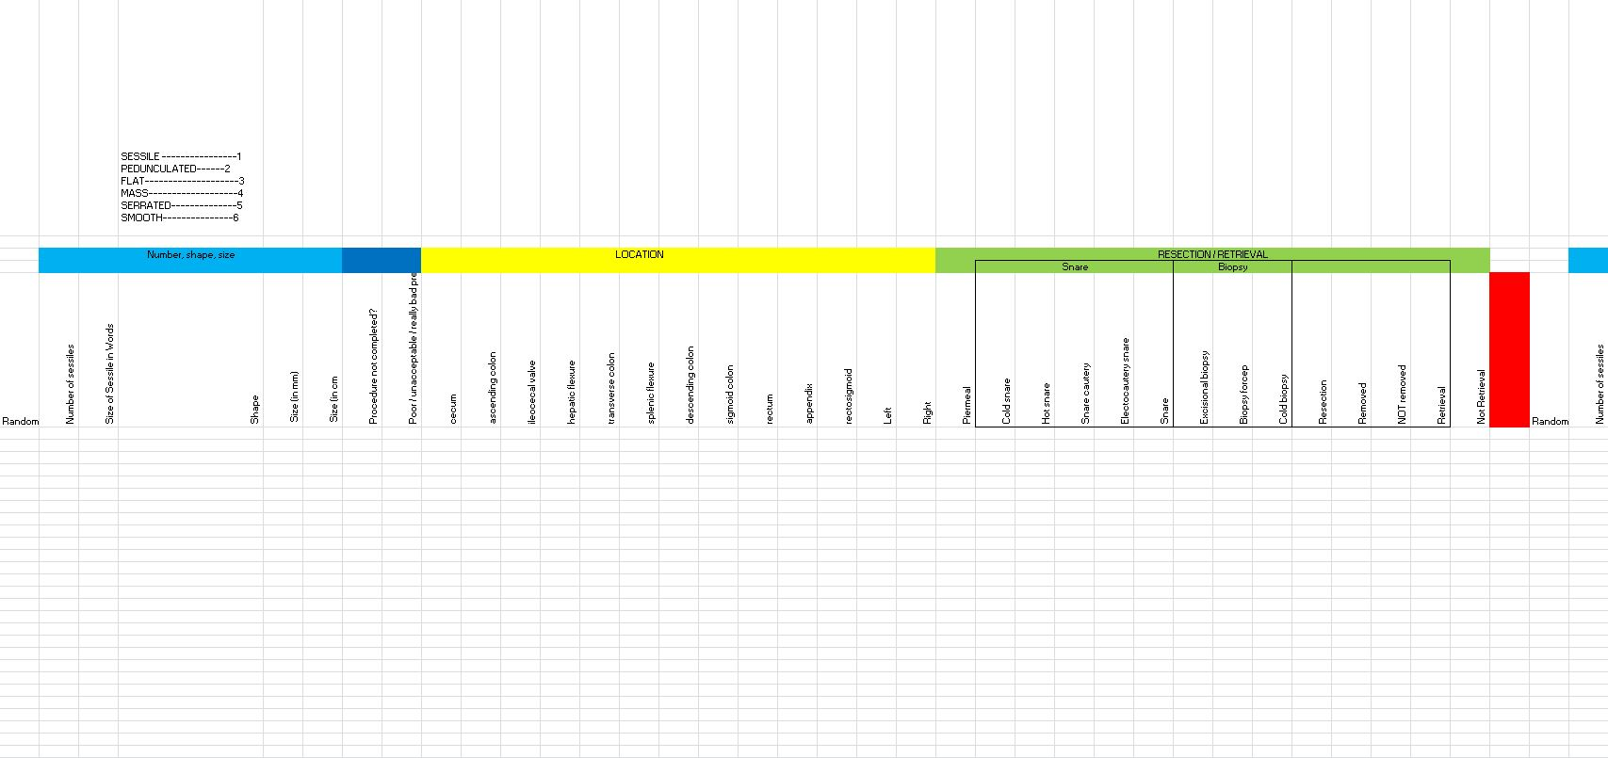

**Instructions for 1st Phase**

